1. Register a new user
   1. Input : userType and userInfo
      1. userType : String that contain the type of the user we have 3 types of users in the system which are Admin , NormalUser and StoreOwner.
      2. userInfo : is a json object that contain the information of user you want to register until now the information we need are the email and password so the json object will be something like this 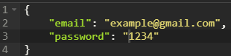
   2. Examples for registering new user
      1. Register NormalUser or StoreOwner
         1. 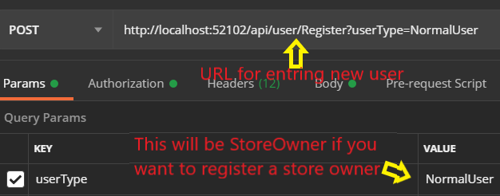
         2. 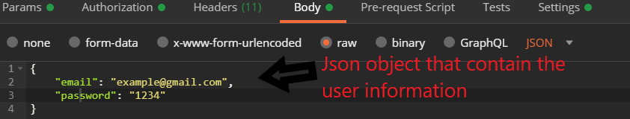
      2. Register an Admin
         1. 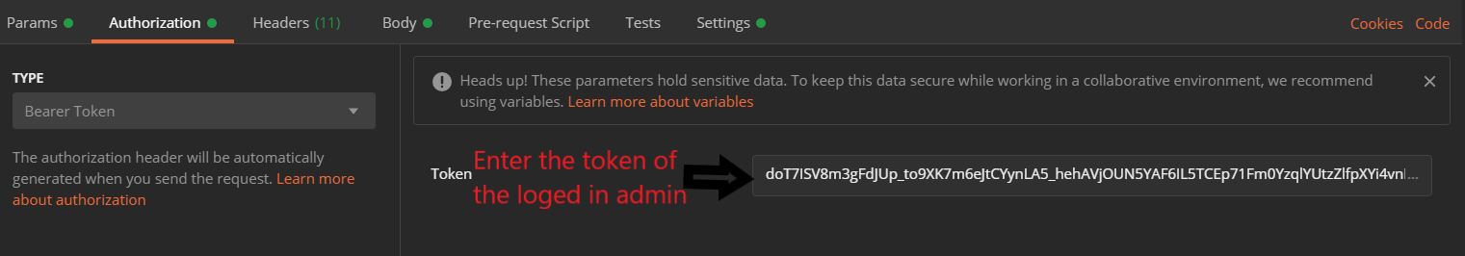
         2. 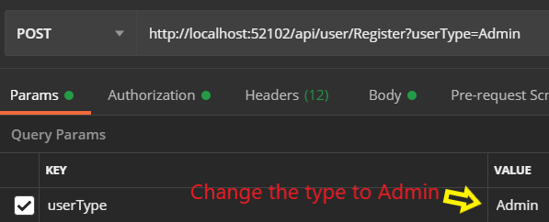
         3. 
   3. Return from registering
      1. True if the registration was successful, false otherwise.
2. Login : here not like the register function we take the input in the URL head in the form of x-www-formurlencoded
   1. Input : userMail and password
   2. Example of how to login
      1. 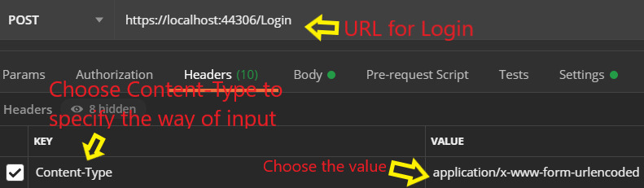
      2. 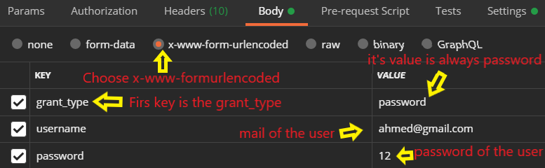
   3. Return type : it will be json object that contain token , type of the token , time to expire , username , time when it was issued and time when it will expires.
      1. 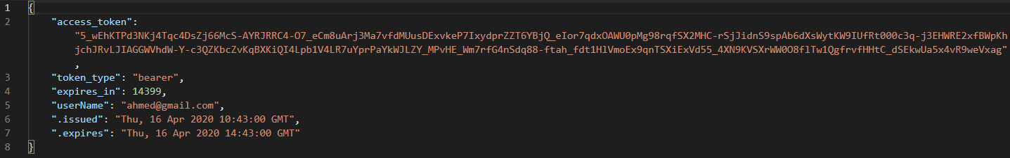
3. List all registered users : the only one how can use it is a logged in admin
   1. Input : no inputs.
   2. Example of how to use it
      1. 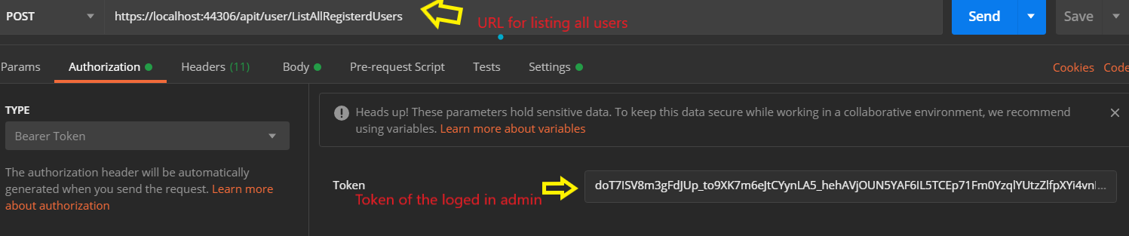
   3. Return value : is a list of all registered users in the system